**EE 464**

**Hardware Project**

**Simulation Report**



**Team 5**

**Student 1 & ID: Alper Soysal & 2305324**

**Student 2 & ID: Hüsnü Oğuz Yorgancılar &**

**Student 3 & ID: Göktuğ Tonay &**

# **Introduction**

In this report, we will make a design decision and select a topology to produce an isolated DC-DC converter. Also, we will analyse this circuit in the simulations and obtain some results. Then, we will select some components according to simulation. Lastly, we will look at the preliminary results of transformer and inductor that we build.

# **Topology Selection**

There are many topologies to design an isolated DC-DC converter such as flyback, forward, push pull etc. Each of them has some advantages and disadvantages. So, we want to select the topology as different from the other hardware project. As a result, we decided to design a “Push Pull Converter”.

**Advantages**

* Good transformer core utilization
* Easier to base drive (low side switching)
* Small Filter and Transformer
* Interleaved Structure

**Disadvantages**

* Voltage stress on the FET’s is twice the input voltage
* Asymmetric switch signals cause a flux walking in the core
* Number of the semiconductors are larger than the other topologies

# **Transformer Design**

In order to determine the turn ratio of the transformer, we can look at the push pull converter voltage equation.

$$V_{out}={2*V}_{in}*D*\frac{N_{2}}{N_{1}}$$

In the design requirements, we know that input voltage varies between the 24V and 48V. Also, push pull converter requires duty cycle which is smaller than the 0.5.

If we put a range for duty cycle such as 0.2 < D <0.4, we can find the necessary turn ratio

$$15=2*48*0.2*\frac{N_{2}}{N_{1}} =>\frac{N_{2}}{N_{1}}=0.78$$

To make the number of turn as integer, we can select the $\frac{N_{2}}{N_{1}}=0.75=\frac{3}{4}=\frac{6}{8}$

Minimum number of turns can be determined as the flux density in the core cannot reach the saturation. So, minimum number of turns can be calculated as following formula.

$$\frac{V_{input-max}*D_{maxi}*\frac{1}{f_{s}}}{{2*B}_{sat}*A_{e}}=N_{1}$$

Then, we can use the effective area of the core. Our first core decision is the TDK Electronics B66335G0000X187 magnetic core. Its effective cross-sectional area is 354 mm2 .

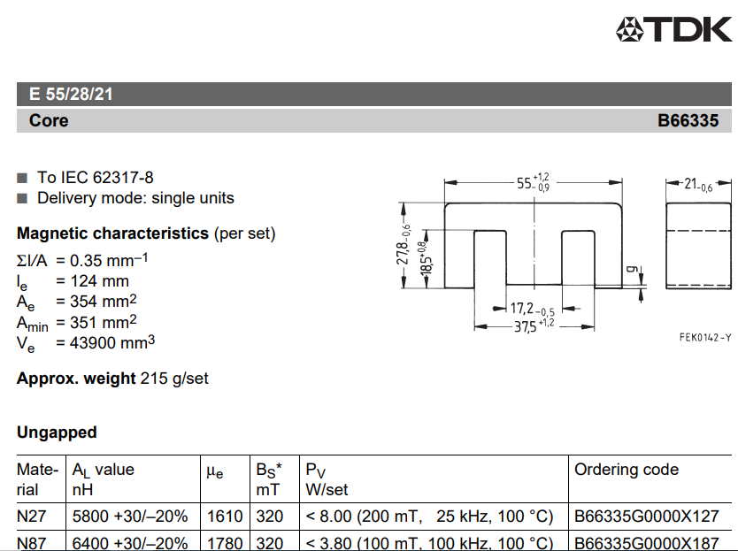

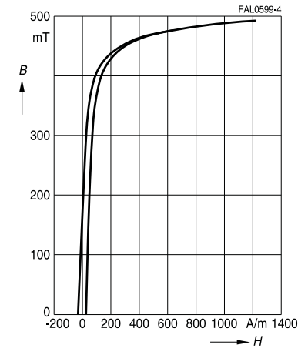

Figure-1: The properties of B66335G0000X187 magnetic core

Maximum flux density varies depends on the material of the core. For a safety, we can select as maximum 0.2 T.

$$N_{1-min}=\frac{48*0.4*\frac{1}{100k}}{2*0.2*354x{10}^{-6}}=1.356$$

So, number of turns 6 and 8 is sufficient.

In the simulation, maximum current is 2.2 A for input, 3.3 A for the output. Also, our core has more window area. So, we decided to use directly a litz cable which has 3 mm^2 area. Then, when we calculate the fill factor, we obtained the following calculation

$$Fill Factor=\frac{\left(8+6\right)*0.3}{\left(10.15*18.5\right)*2}=\%12$$

# **Inductor Design**

# **Preliminary Results**

In order to verify our transformer and inductor design, we should measure the magnetizing inductance and leakage inductance of the transformer, and the inductance of the inductor. Also, primary and secondary resistances are obtained. These values are measured using LCR meter as seen in Figure-2&3. The magnetizing inductance seen from primary is 103.3µH, the leakage inductance is 3.83µH, and resistance is 1.02Ω. In addition, the inductance of the output inductor is measured as 43µH with an ESR of 245mΩ as seen in Figure-4.

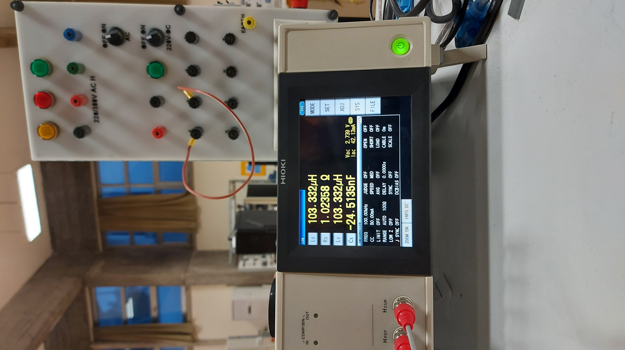

Figure-2: Magnetizing inductance and primary resistance

metin, iç mekan içeren bir resim

Açıklama otomatik olarak oluşturuldu

Figure-3: Leakage inductance,

metin, iç mekan, elektronik eşyalar içeren bir resim

Açıklama otomatik olarak oluşturuldu

Figure-4: Inductance of output inductor

# **Simulation Results**

# **Component Selection**

In a push-pull converter, we mainly need a controller, transistors for switching, transformer, diode for rectification and inductor for filtering. We already discussed about inductor and transformer in this report. We will start with the discussing about component selection with controller for our converter.

As already mentioned about in the topology selection part, push pull converter has some disadvantages. First and main one is, asymmetry due to manufacturing errors and tolerances, cause flux walking in the core. Flux walking can be defined as accumulation of the flux in the core due to non-zero net flux in a cycle. This non-zero net flux will be add up in the time and will cause saturation of the core. There will be constantly increasing DC component of the flux of the core. In the low frequency transformers like in the mains transformers, resistive components of the windings control this problem. However, in a high frequency transformer in our case, resistive component of the winding is not enough to solve. This means that in a realistic push-pull converter will create a non-zero net flux in the core every cycle which add up with the previous one. If we plot the flux in the core, it will look like it is walking or in a stair shape. To solve this problem, current control can be used. In current mode control, duty cycle of the switched will be controlled according to the current passing through each switch. Average or peak current can be used to control.

Due to that problem, our controller must have current mode control. With that input we searched for controllers and find two options.

1. **UC3846N:**

Basic structure of this controller can be seen below.

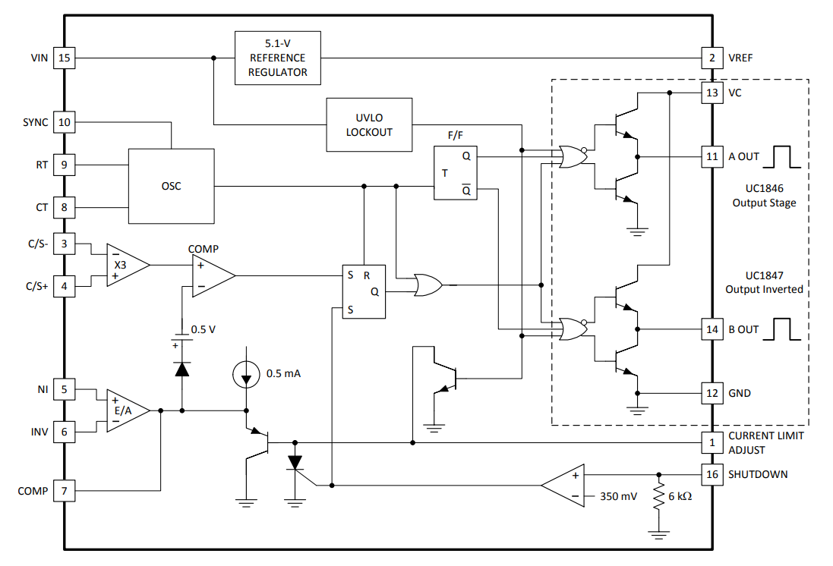  
Figure-5: Block diagram of UC3846

**Advantages:**

* Easily available in Turkey
* All required blocks for control and drive the low side switches are included
* DIP package, easily used in the hand manufactured PCB
* Differential Current sense reduces the common mode noise in the sense line

**Disadvantages:**

* Maximum voltage in the Vin is limited with 40V requires external regulators for working above 40V.
* 500mA sink/source gate drivers can be problematic for 100kHz operation.
* Optic isolation will modify the control loop.

1. **LM5030:**

Basic structure of the controller can be seen below.

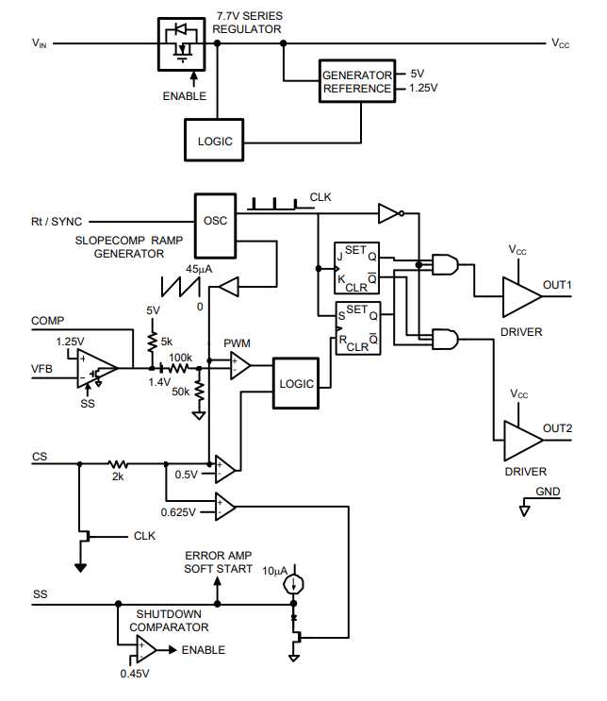  
Figure-6: Block diagram of LM5030

**Advantages:**

* Can be found in the global component stocks
* All required blocks included
* Designed for isolated controller
* Vin accepts voltage up to 100V, no external regulator needed
* 1.5A gate drivers
* Slope compensation
* Good reference design and resources

**Disadvantages:**

* Comes in a small MSOP package, which have a very small pitch for hand manufactured PCB.